**Assignment 1(D)**

**Restatement and Summary**

This study focuses on the impact of gentrification on Greater Adelaide neighbourhood. Adelaide's rents are among the affordable in the country but have risen faster than other capital cities in the past year where the median advertised rental price for an Adelaide property jumped by 11.8 per cent in 2022, reaching a record $450 a week (Brown 2023). It is worth to explore if this indicator might affect another neighbourhood and what the potential patterns could look like. To have a better understanding, various indicators and characteristic of the neighbourhood including changes in rental housing prices, social infrastructure, income levels, education levels and more.

Data was collected from various sources, including the Australian Bureau of Statistics (ABS) and complementary data on walking scores and social liveability indexes. Exploratory Data Analysis (EDA) was conducted to visualize the distribution of indicators across suburbs and identify potential patterns related to gentrification.

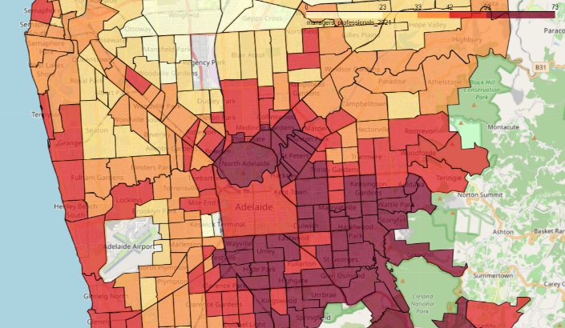Indicators that could potentially indicate that neighbourhood is undergoing gentrification include changes in the percentage of people aged 18 and under (Kolko 2007, p.25), professional’s worker (Baker 1997, p. 8), completed tertiary education based, and household income above $3000 and rental housing price to identify potential gentrification patterns (Koulizos 2015, p.34). For example, Figure 1a and 1b display the distribution of professionals in the workforce while Figure 2a and 2b display the distribution of completed tertiary education. It was observed the changes in suburbs were located within 3-5km radius around Adelaide CBD. This trend is comparable to Pegler and Thackaway studies where gentrification hotspots expanded outward from the city area (Thackway et al. 2023, p.5).

Figure 2a: Distribution of completed tertiary education in Adelaide for 2016 census.

Figure 2b: Distribution of completed tertiary education in Adelaide for 2021 census.

Figure 1a: Distribution of Professionals in Adelaide for 2016 census.

Figure 2b: Distribution of Professionals in Adelaide for 2021 census.

To predict gentrification, three machine learning regressor models - Linear Regression, Support Vector Regressor (SVR), and Kernel Ridge Regressor (KRR) were utilized to predict the future SEIFA scores. These models were trained using the 2016 input variables to predict the 2021 SEIFA index. The concept was to predict SEIFA 2021 score using input variables of 2016. Utilizing the best-performing model, the unknown 2026 SEIFA score for Adelaide suburb areas was predicted using 2021 input variables. The performance of each model was evaluated based on metrics such as R-squared (R2) score and Root Mean Square Error (RMSE).

KRR and SVR models were utilized because their capability to capture the multilevel socioeconomic factors and nonlinear interactions in the dataset. Both models employing the kernel trick, enabling them to learn the non-linear function without the need to explicitly transform the input dataset into higher-dimensional space (Hu et al. 2018, p. 663). When measuring the performance of KRR and SVR, both RMSE values were doing very well indicating that the model can capture the underlying patterns in the data and provide accurate predictions. SVR has been implemented in predicting and attempting to learn about housing research prices and yielding a good performance in forecasting real estate prices (Kema 2020, p.15). Consequently, this study replicates similar method as real estate prices is one the predictors.

Figure 4: Model performances

Figure 3: Scatterplot chart between Predicted and Truth values.

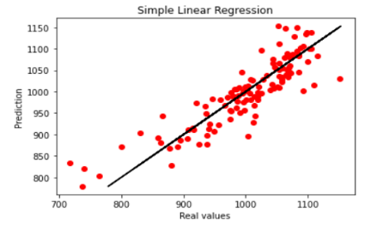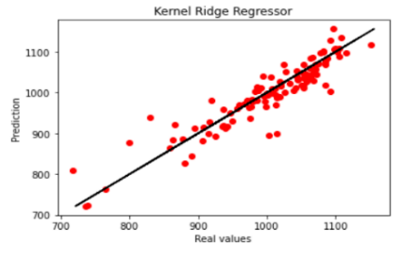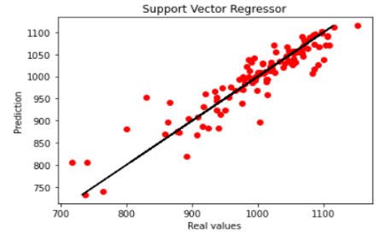

To achieve the best model predictions, both KRR and SVR have been maximized by manipulating their hyperparameters. Based on Figure 4, following the tuning process, both models demonstrated well, registered at 85% score. As depicted in Figures 6, 7 and 8, once again, the pattern of the SEIFA score fluctuation was located 3-5km radius around Adelaide CBD spanning from 2016 to 2021 and predicted into 2026.

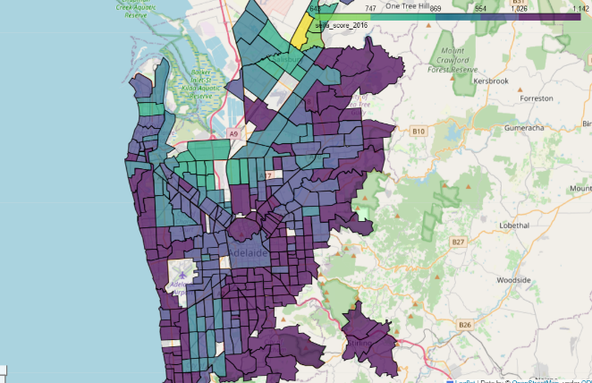

Figure 6: SEIFA score for 2016

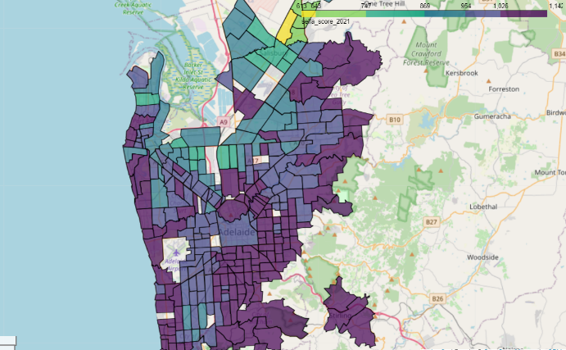

Figure 7: SEIFA score for 2021

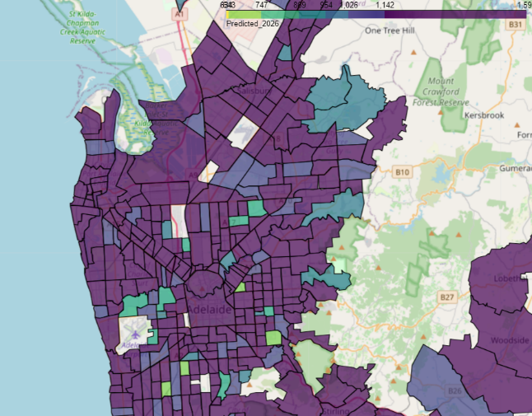

Figure 8: SEIFA score for 2026

The ranking process was adopted from Thackway et al. (2023) approach. Suburbs were arranged highest to lowest according to their differences in SEIFA score. If the difference above one standard deviation, the suburb was classified as 'gentrifying' while within the range of one standard deviation were classified as 'not gentrifying' (Thackway et al. 2023, p.5). Based on Figure 9 and 10, one constraint of this approach was that suburbs with small changes, even though they already have a high SEIFA score, would not be captured (Thackway et al. 2023, p.5). This approach was mainly concerned to explore suburbs that would experience early gentrification rather than already gentrified (Thackway et al. 2023, p.5).

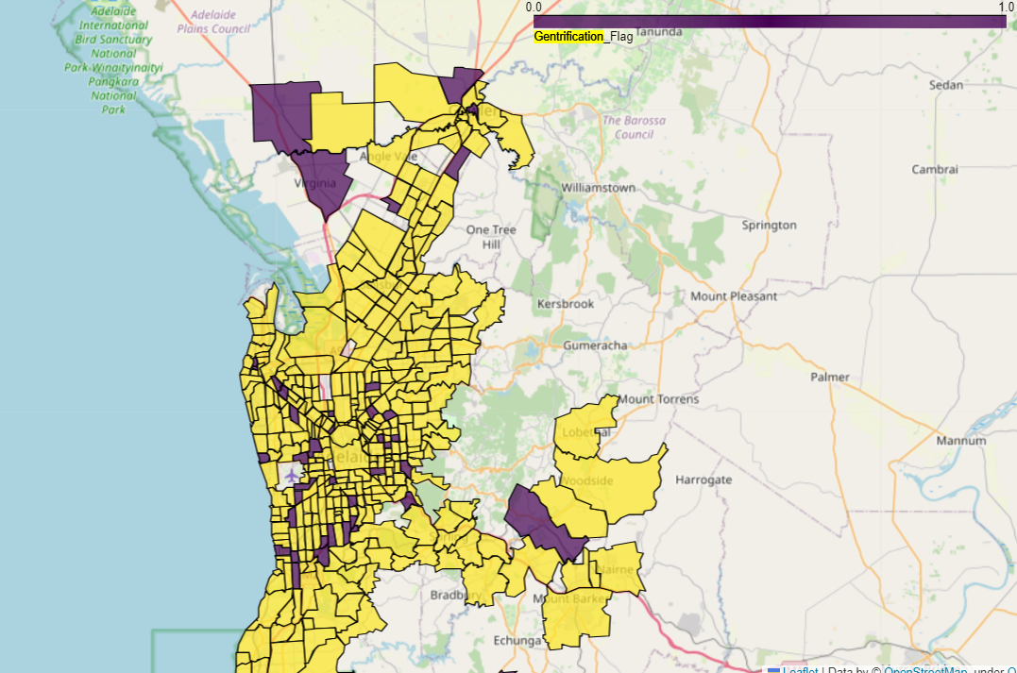

Figure 9: Suburbs undergo gentrification using predicted 2021 SEIFA score.

Figure 10: Suburbs undergo gentrification using predicted 2026 SEIFA score.

**Improvement of Solution**

Using ABS data, it was observed how the predictors correlated with SEIFA score. The correlation was notably strong with the variables as per Figure 1 and Figure 2. The pattern of the gentrified suburbs was moving in radial from the centre of Adelaide CBD. This suggests predicted the hotspots of gentrification might expanded outward from the city area.

Figure 11: Correlation to SEIFA score

As shown in Figure 4, the correlation was ranked by SEIFA score 2021, its exhibits that people completed tertiary education, professional’s workers and median personal income were associated with an increase in expected SEIFA score, whereas a lower number of persons aged 18 years and below had a negative correlation.

However, measuring gentrification solely on ABS data might not capture the complete picture of gentrification process give its complexity and need to be investigated from various sources. To assess gentrification, different approach could be done on the ground such as qualitative research through surveys. Conducting interviews door-to-door, interviewing could capture the granular information (Tulier et al. 2019, p. 102173). Moreover, gentrification could also be measured with the incoming highway across the neighbourhoods. In Adelaide, neighbourhoods that undergo highway constructions might experiencing neighbourhood changes as those in proximity to highways could have higher home values due to improved accessibility (Zuk et al. 2018, p.34).

**Conclusion and Future Work**

In summary, this research provides insights into the potential impact of gentrification in Adelaide. By utilizing data-driven approaches and machine learning models, the study identifies potential gentrification areas and helps in understanding the changes in suburbs over time. The results can assist policymakers and urban planners in making informed decisions to address the challenges of gentrification and its effects on the community.

**References**

Baker, E 1997, ‘Gentrification and gender effects in North Adelaide’, Thesis (B.A.(Hons.)) --University of Adelaide, Dept. of Geography, 1998.

Brown, J 2023, *Adelaide rents at record high yet still among nation’s most affordable*, Realestate, viewed 11 June 2023, < <https://www.realestate.com.au/news/adelaide-rents-at-record-high-yet-still-among-nations-most-affordable/>>

Hu, L, He, S, Han, Z, Xiao, H, Su, S, Weng, M & Cai, Z 2019, ‘Monitoring housing rental prices based on social media:An integrated approach of machine-learning algorithms and hedonic modeling to inform equitable housing policies’*, Land Use Policy*, vol. 82, pp. 657–673.

Kolko, J 2010, ‘The determinants of gentrification’*, SSRN Working paper Series*.

Koulizos, P 2015, ‘Are there indicators that can be used as predictive precursors to identify gentrification within an area?’, Master Thesis of Urban and Regional Planning, University of Adelaide,Adelaide,https://www.researchgate.net/publication/305390186_Are_there_indicators_that_can_be_used_as_predictive_precursors_to_identify_gentrification_within_an_area.

Kema, S, ‘Geography and AI: a happy marriage? Exploring the potential of Machine Learning as a new method in geographic research.’ Master Thesis Economic Geography, University of Groningen, Groningen, https://frw.studenttheses.ub.rug.nl/3365/1/thesis-EG-final_Steven-Kema.pdf.

Thackway, W, Ng, M, Lee, C-L & Pettit, C 2023, ‘Building a predictive machine learning model of gentrification in Sydney’, *Cities*, vol. 134, p. 104192–.

Tulier, ME, Reid, C, Mujahid, MS & Allen, AM 2019, ‘“Clear action requires clear thinking”: A systematic review of gentrification and health research in the United States’, *Health & Place*, vol. 59, pp. 102173–102173.

Zuk, M, Bierbaum, AH, Chapple, K, Gorska, K & Loukaitou-Sideris, A 2018, ‘Gentrification, Displacement, and the Role of Public Investment’, *Journal of Planning Literature*, vol. 33, no. 1, pp. 31–44.